SCHOOL OF COMPUTER SCIENCE AND ARTIFICIAL INTELLIGENCE |  |  |  |  | DEPARTMENT OF COMPUTER SCIENCE ENGINEERING
Program Name: B. Tech |  |  |  | Assignment Type: Lab |  |  | Academic Year:2025-2026
Course Coordinator Name |  |  |  | Venkataramana Veeramsetty
Instructor(s) Name |  |  |  | Dr. V. Venkataramana (Co-ordinator)  Dr. T. Sampath Kumar  Dr. Pramoda Patro  Dr. Brij Kishor Tiwari  Dr.J.Ravichander  Dr. Mohammand Ali Shaik  Dr. Anirodh Kumar  Mr. S.Naresh Kumar  Dr. RAJESH VELPULA  Mr. Kundhan Kumar  Ms. Ch.Rajitha  Mr. M Prakash  Mr. B.Raju  Intern 1 (Dharma teja)  Intern 2 (Sai Prasad)  Intern 3 (Sowmya)  NS_2 ( Mounika)
Course Code |  |  | 24CS002PC215 | Course Title |  | AI Assisted Coding
Year/Sem |  |  | II/I | Regulation |  | R24
Date and Day  of Assignment |  |  | Week 8 - Friday | Time(s)
Duration |  |  | 2 Hours | Applicable to  Batches
AssignmentNumber:16.1(Present assignment number)/24(Total number of assignments)
 | Q.No. | Question |  |  |  |  |  | Expected Time  to complete
 | 1 | Lab 16 – Database Design and Queries: Schema Design and SQL Generation  Lab Objectives:  - Understand schema design principles for relational databases.  - Use AI-assisted tools to generate SQL schema definitions.  - Write and refine SQL queries (CRUD + aggregate operations).  - Explore how AI can optimize queries and ensure normalization.  Task 1: Online Bookstore Schema Design  Scenario:  SR University is setting up an online bookstore to manage books, authors, publishers, and customer orders.  - Use GitHub Copilot to generate a SQL schema for tables: Books, Authors, Publishers, and Orders.  - Ensure proper primary keys, foreign keys, and constraints.  - Insert at least 5 sample records into each table.  - Write queries (with Copilot assistance) to:  - Retrieve all books published by a specific publisher.  - Find the total number of orders made by each customer.  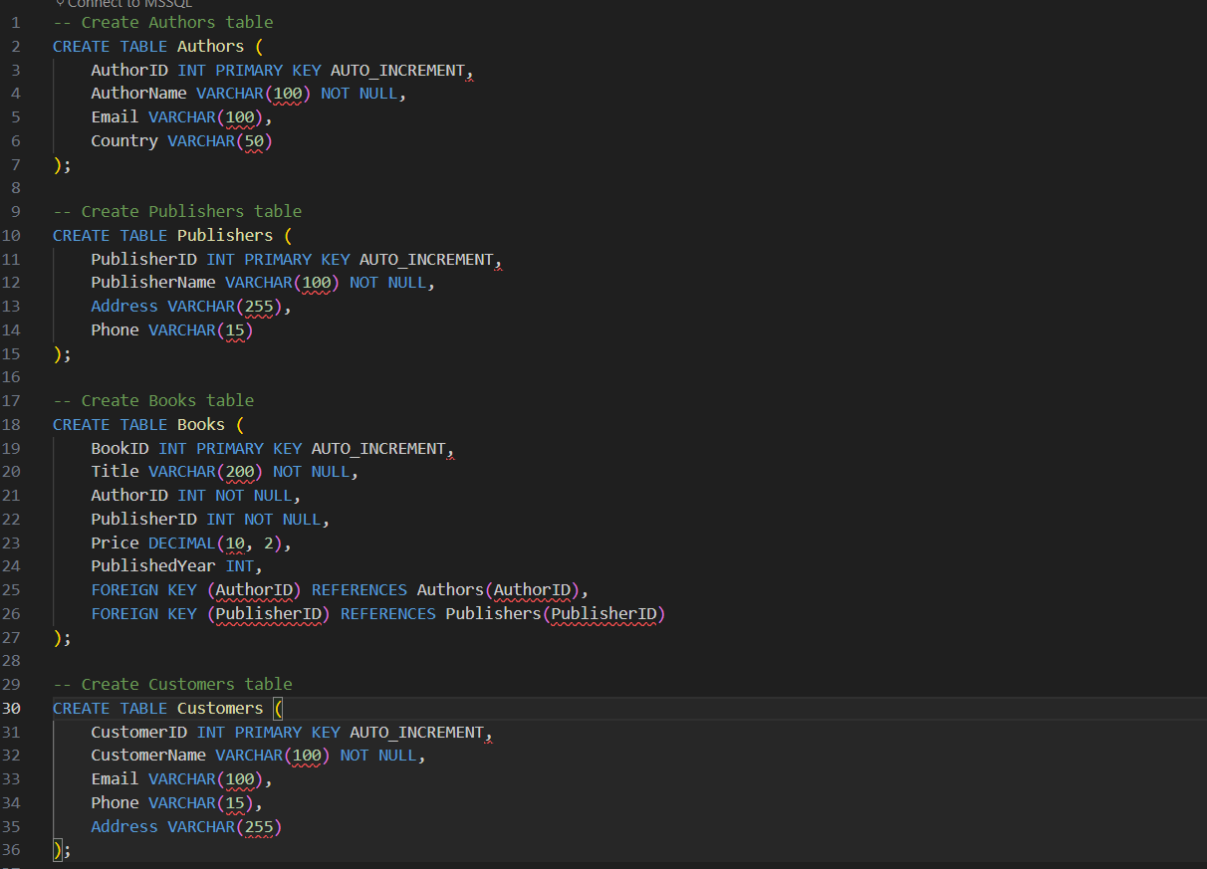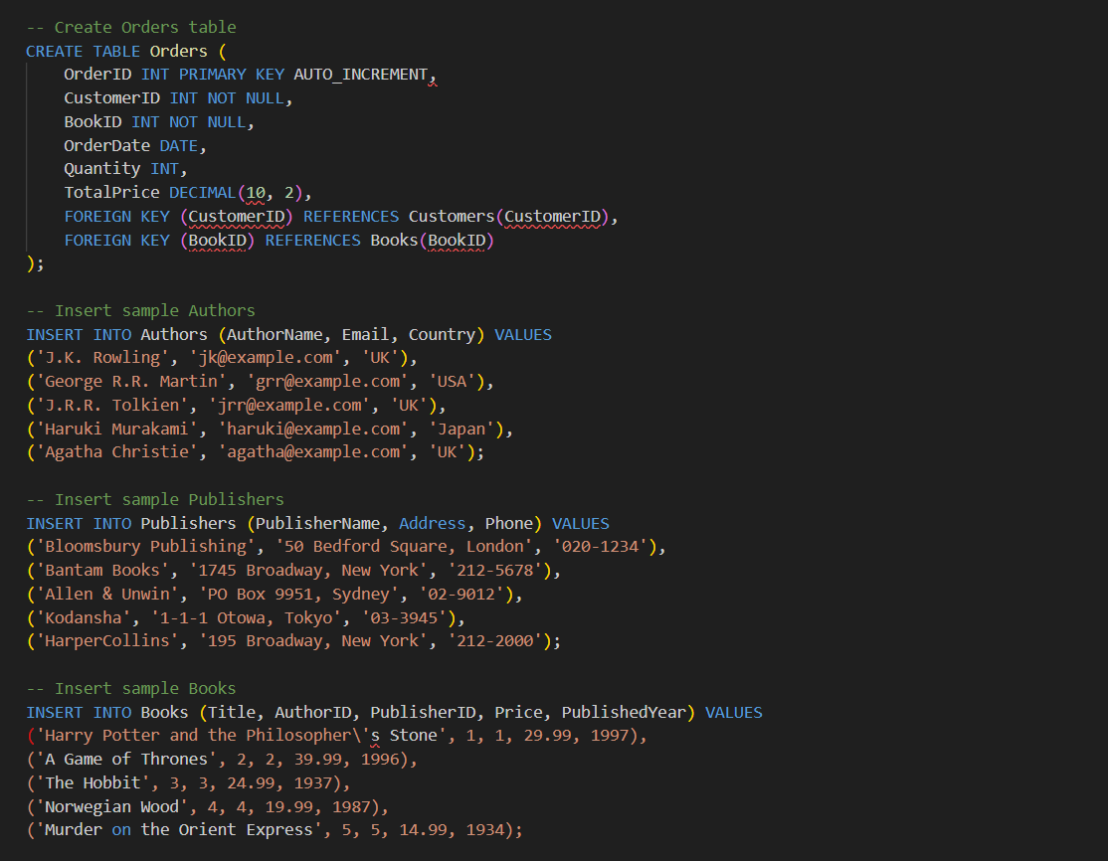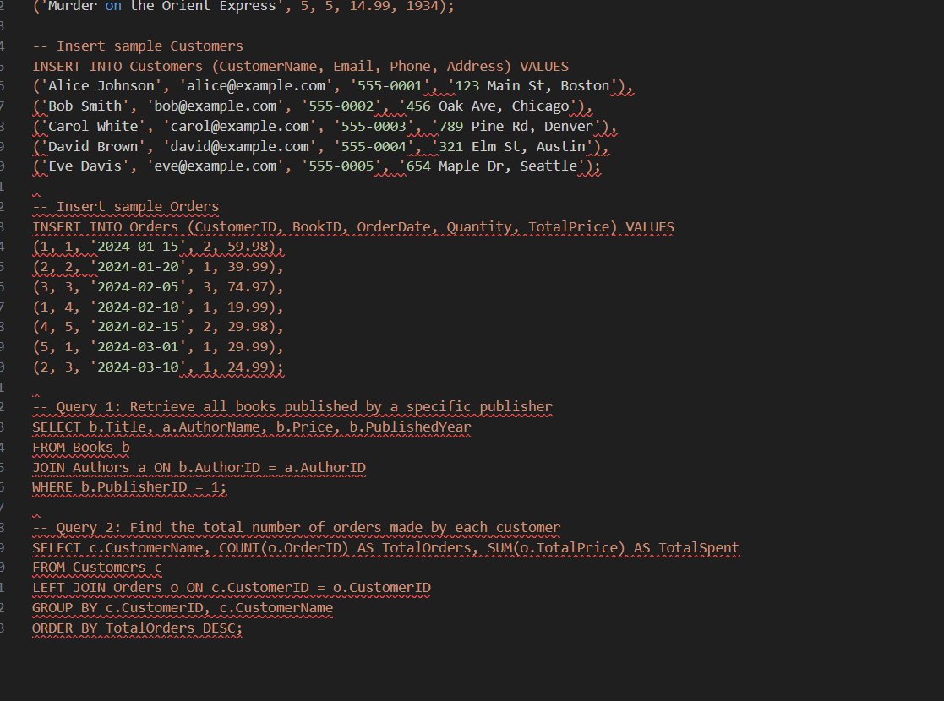  Task 2: Hospital Management System Queries  Scenario:  A hospital wants to maintain data about patients, doctors, appointments, and treatments.  - Create a database schema for the hospital system with the above entities using Copilot suggestions.  - Write SQL queries to:  - List all patients who have appointments with a specific doctor.  - Retrieve the top 3 doctors who have the maximum number of appointments.  - Generate a report of patients along with their assigned treatments.  - Test and refine queries with Copilot assistance.  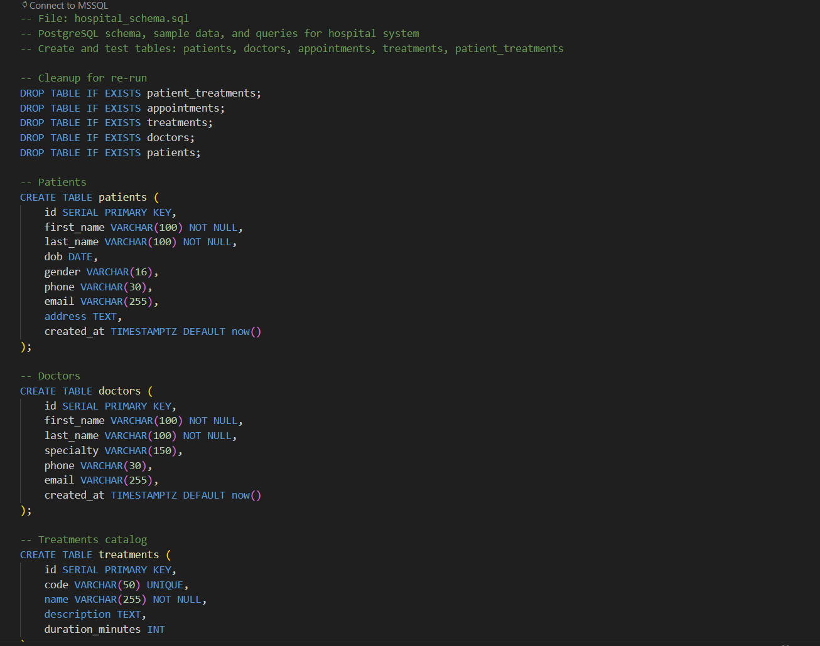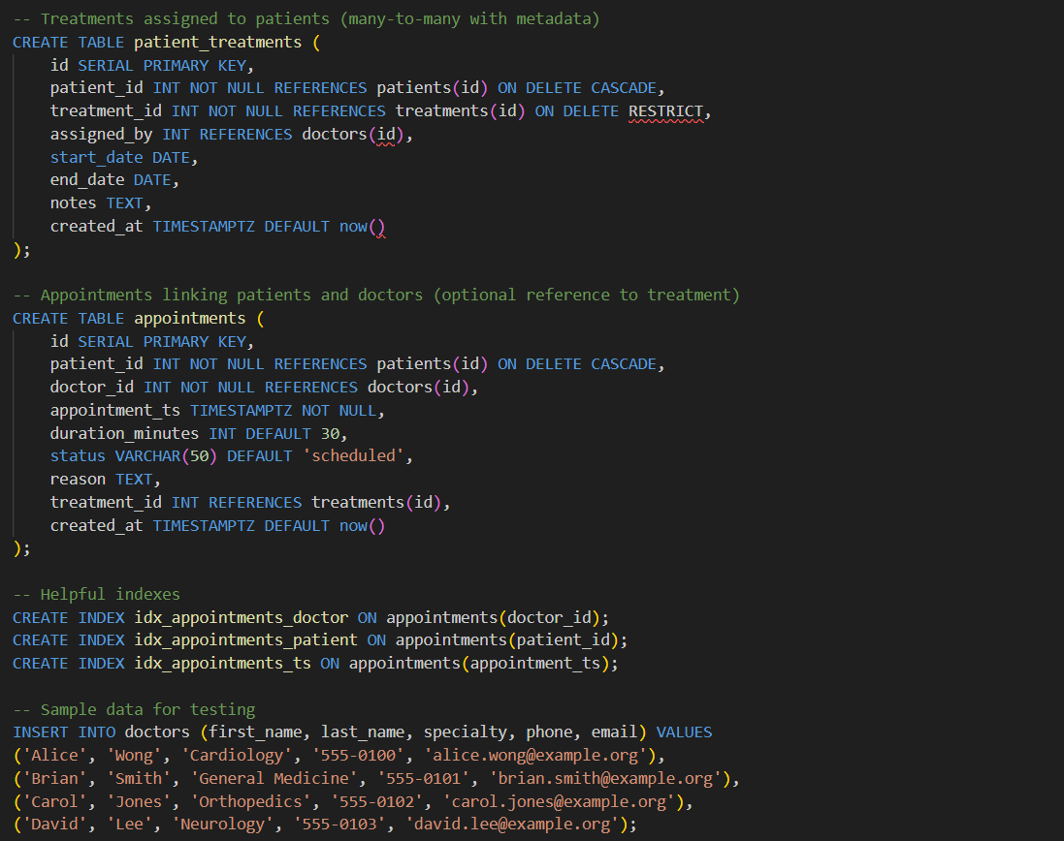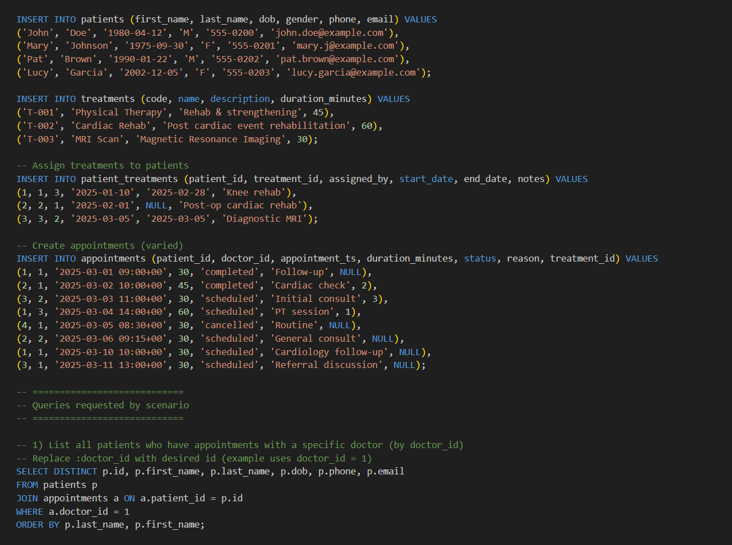  Task 3: University Course Registration  Scenario:  SR University needs a course registration system for students enrolling in different courses under faculty supervision.  - Use Copilot to design schema tables: Students, Courses, Faculty, and Registrations.  - Define relationships:  - Each student can register for multiple courses.  - Each course is taught by a faculty member.  - Write SQL queries to:  - List all students enrolled in a specific course.  - Find faculty members teaching more than 2 courses.  - Retrieve courses with the highest number of registrations.  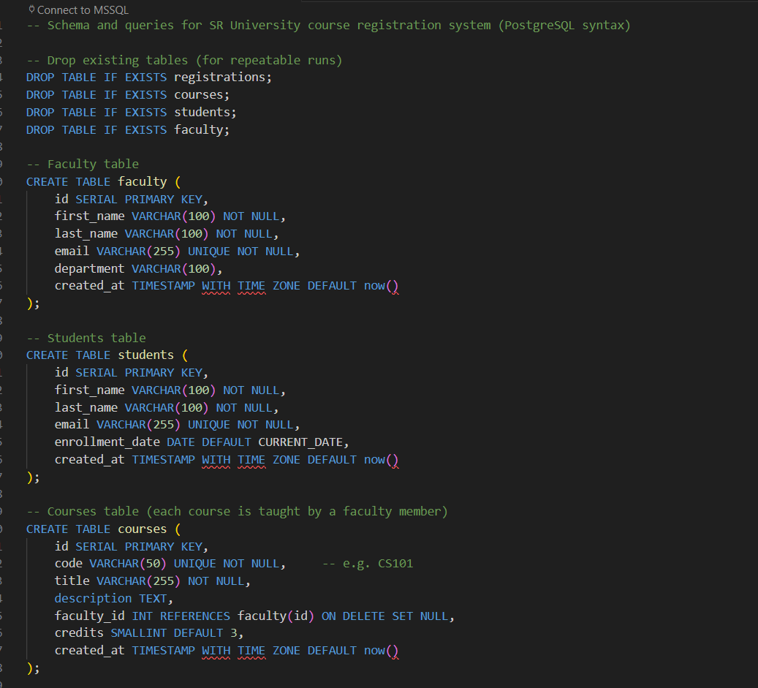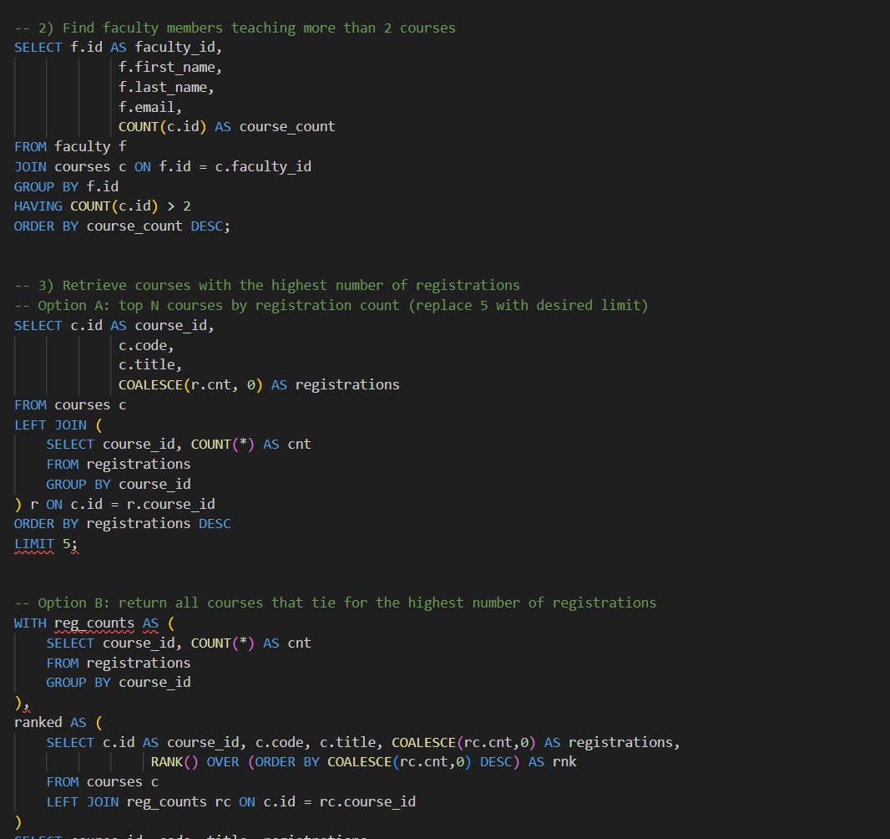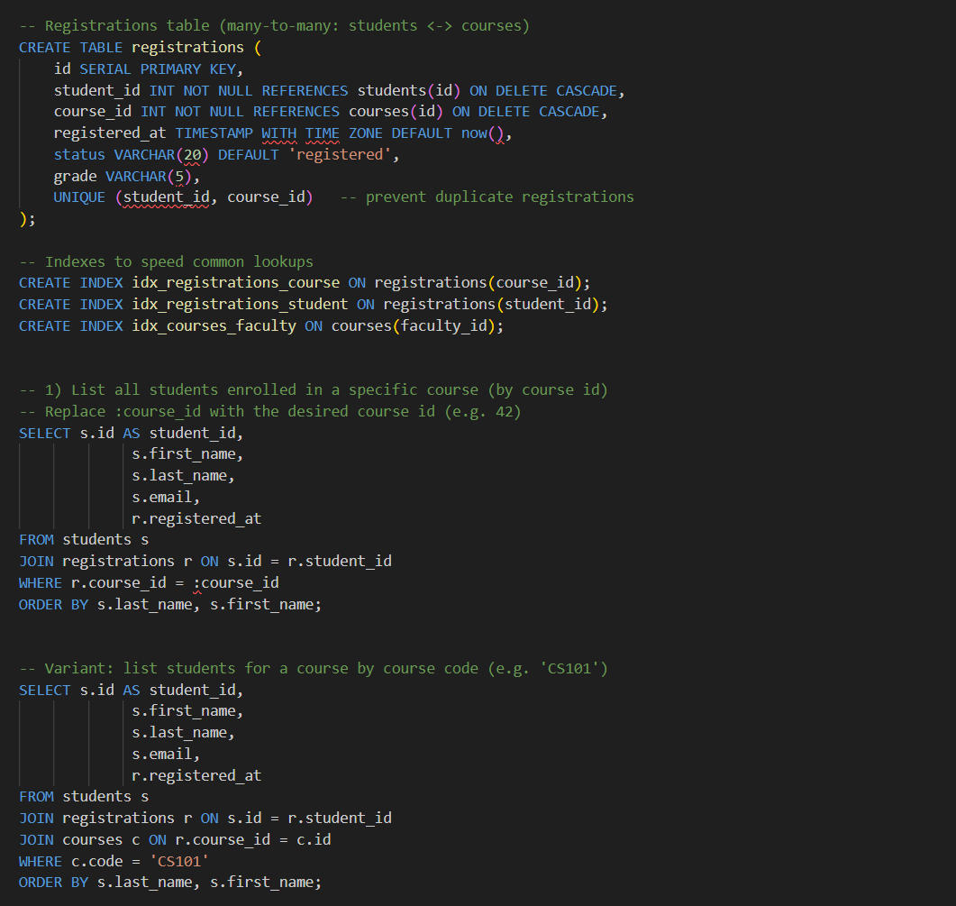  Task 4: E-Commerce Sales Analysis  Scenario:  An e-commerce platform wants to track customers, products, orders, and payments.  - Use GitHub Copilot to generate the schema design with appropriate relationships.  - Insert sample data for customers, products, and orders.  - Write SQL queries to:  - Find the top 5 products by sales revenue.  - Identify customers who have not placed any orders.  - Calculate monthly sales totals for the last 6 months.  - Use Copilot to optimize queries where necessary.  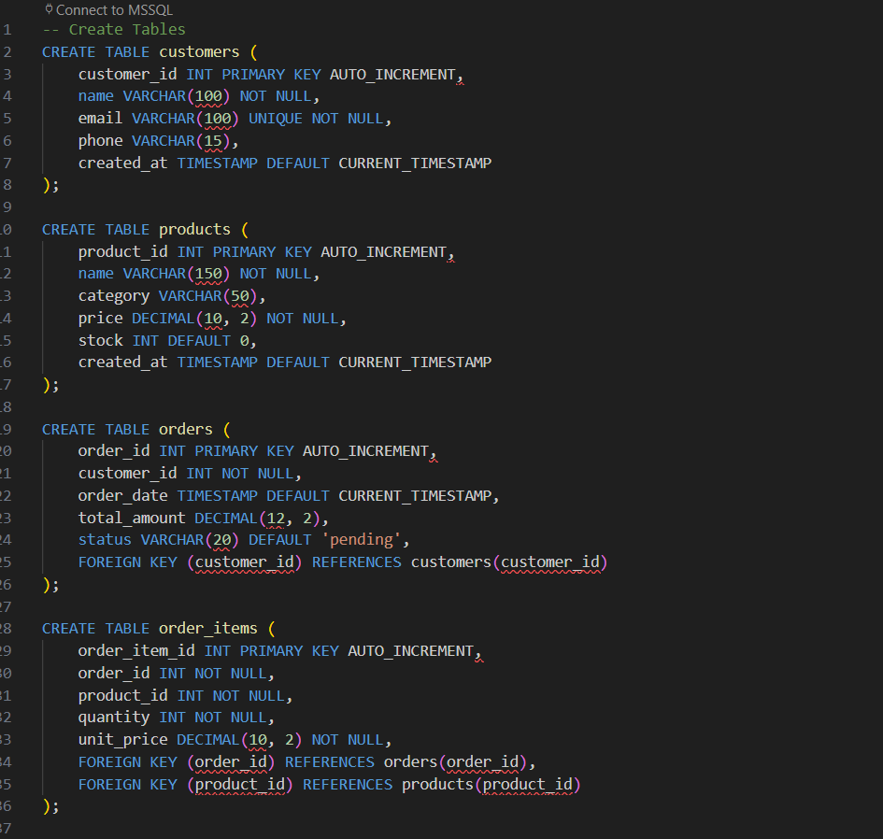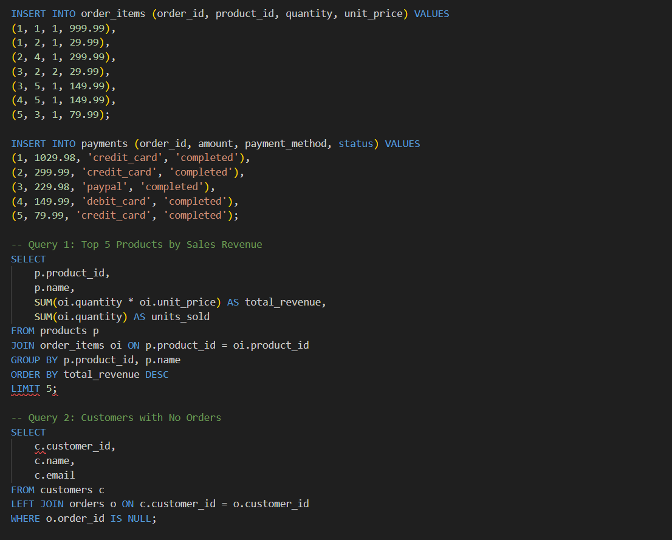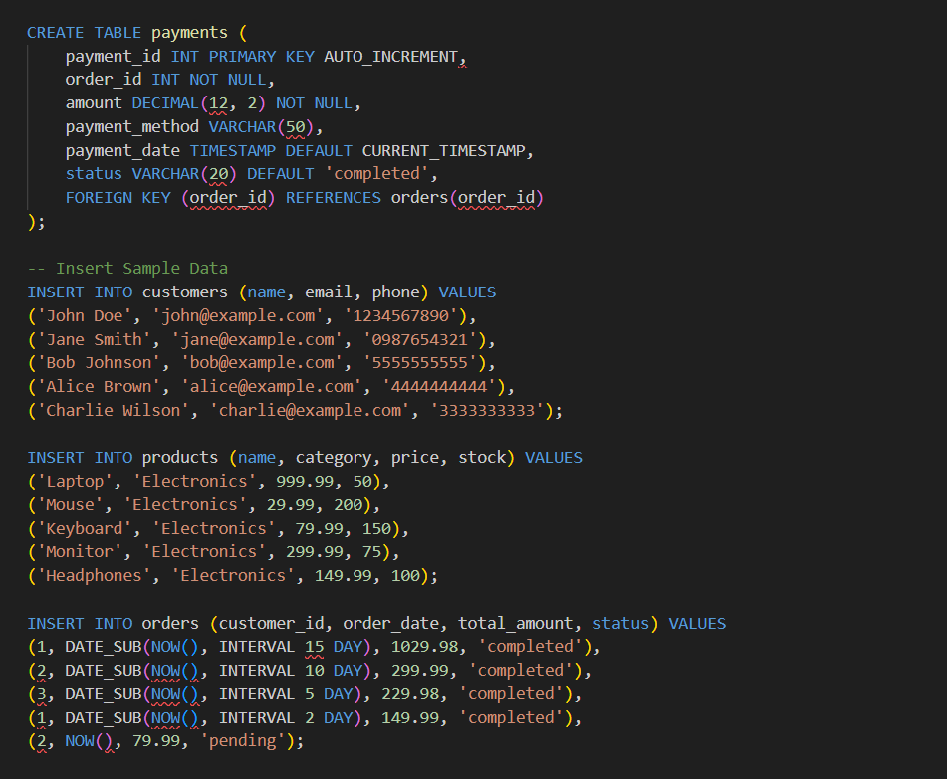 |  |  |  |  |  | Week 8 - Friday

